8 Queen Problem
Aim:
To place eight queens on a chessboard such that no two queens attack each other.
Procedure:
- Start with an empty chessboard.
- Place a queen row by row.
- Check whether the position is safe.
- If safe, place the queen; otherwise, try the next column.
- Use backtracking when necessary.
- Display the valid arrangement.
Output:
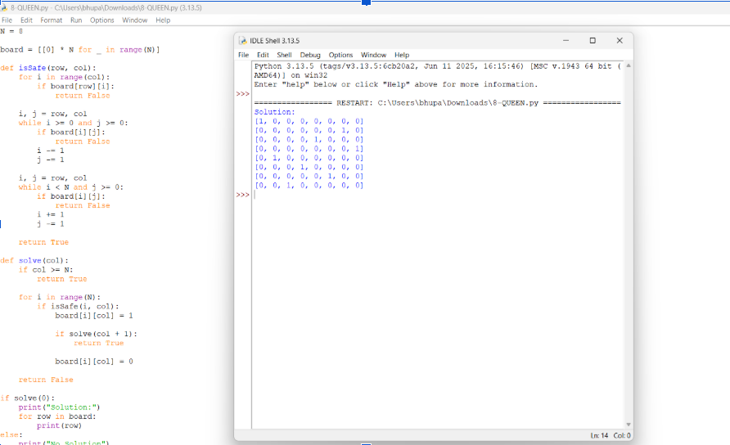
Result:
The 8-Queen problem was solved successfully using the backtracking algorithm.

